Dynamic Analysis
Perform Analysis Procedure

Revision
Version 1
10/31/25 1:13 PM

SME
Charles Wilson

Abstract
This document describes the procedure used to perform the perform analysis activity described in the AVCDL ^{[1]} secondary document Dynamic Analysis Report ^{[2]}.

Group / Owner
Security / Security Architect

Motivation
This document is motivated by the need to have runtime-specific, cybersecurity-related feedback in the development of software for use within safety-critical, cyber-physical systems.
Note: Within the context of this document, the terms security and cybersecurity are used interchangeably. It is presumed that the term security is being used in reference to cybersecurity and not physical security.

License
This work was created by Torc Robotics and is licensed under the Creative Commons Attribution-Share Alike (CC BY-SA-4.0) License.
https://creativecommons.org/licenses/by/4.0/legalcode

Audience
The audience of this document is the cybersecurity practitioner who will be conducting cybersecurity-specific dynamic analysis.

Completeness of Output
Since dynamic analysis is an as-is analysis, it is critical to ensure that the information gathered is as accurate and complete as possible. As with any cybersecurity assessment, it is not the place of the cybersecurity SME to make assumptions on the part of engineering. All information should be sourced from and confirmed by the owner of the element under consideration.

Disposition of Output
This activity does not produce documentation as an output.

Entry Criteria
This document assumes that the reader understands the purpose of cybersecurity-specific dynamic analysis. Further, that the reader has read and understood the AVCDL Dynamic Analysis Report ^{[2]} secondary document.

Prerequisites – Input Materials
It is required that the cybersecurity SME acquire all relevant documentation related to the tool under consideration necessary to complete the procedure.

Instrument Element Activity
The workflow diagram for the perform analysis activity of the Dynamic Analysis process is shown below.
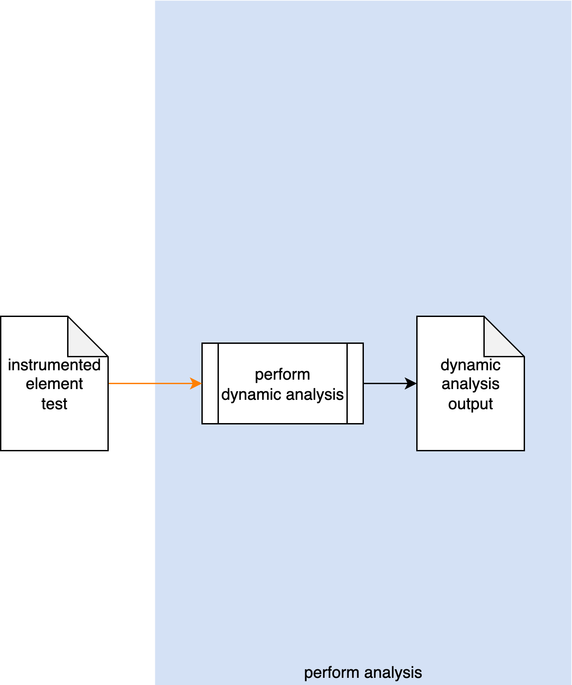
The build system invokes the Dynamic Analysis tool on the Instrumented Element Test. The generated output is captured into Dynamic Analysis Output.
Note: As shown above, this activity is presumed to be performed within the CI/CD pipeline, and as such requires no participation by people.

Methodology
If the preceding two activities of establishing the settings and instrumenting the element have been properly followed, this activity should just work. Its inclusion should therefore be simply to provide completeness to the dynamic analysis process. Any issues which arise should fall into one of the categories covered in the next section.

Considerations
The following items were introduced in the Dynamic Analysis Instrument Element Procedure document. We come back to them because although they should have been addressed during the instrumentation process and the pre-flight of the test within the CI/CD system, these may still need to be addressed within the context of the live CI/CD process.

Termination on Error
Most dynamic analysis tools default to a termination-on-failure behavior. It is therefore important to adjust the test suite to take this into consideration.

Issue Occlusion
Discovered issues may mask more fundamental ones. Be sure to adjust the test to verify that the issue discovered is the root issue.

Cybersecurity Side-effects
An important consideration is that because dynamic analysis require intrusive access to data structures within the code, there may be a significant impact on other cybersecurity-related tooling. These should probably be disabled in order to not trigger false positives in those tools.
Note: Footprint is not discussed here because the CI/CD pre-flight is assumed to have caught issues related to it.

Exit Criteria
This procedure is considered complete once the Dynamic Analysis Output has been generated.

References
- AVCDL (AVCDL primary document)
- Dynamic Analysis Report (AVCDL secondary document)
- Dynamic Analysis Instrument Element Procedure (AVCDL tertiary document)

